1. Website Specifications
- Website Objective and Goals
The objective of the website is to design and develop a FIFA website called “FIFA Fan Hub”. The website aims to provide users with up-to-date information about football, including teams, match fixtures, news, results, player profile and statistics.
The goals of the website are:
- To inform users about international football events and teams
- To provide detailed profiles of popular football players
- To enhance user engagement through interactive content such as forms and navigation
- To create an attractive and user-friendly interface that appeals to football fans

- Target Audience
The target audience for this website includes:
- Age Group: 15 – 40 years
- Gender: All genders
- Interests: Football, sports news, FIFA competitions,
- Location: Global audience (especially football fans)
- Technical Ability:
  - Basic to intermediate internet users
  - Familiar with browsing websites and using mobile devices

- Type of Website
This is a sports information and entertainment website.
It focuses on delivering football-related content such as:
- Team information
- Player profiles and statistics
- Match fixtures and results
- Sports news
- Fan interaction through a contact/feedback form

2. Information Design & Taxonomy
- Information Architecture
The website content is organized into clear categories to ensure easy navigation and accessibility.
Main Sections (Pages):
- Home
- Teams
- Players
- Matches
- News
- Contact
- Feedback
- Site Map (Navigation Structure)
- Home (index.html)
- │Navigation Bar
- Teams (teams.html)
- Players (players.html)
- Matches (matches.html)
- News (news.html)
- Contact (contact.html)
- Feedback(feedback.html)
- 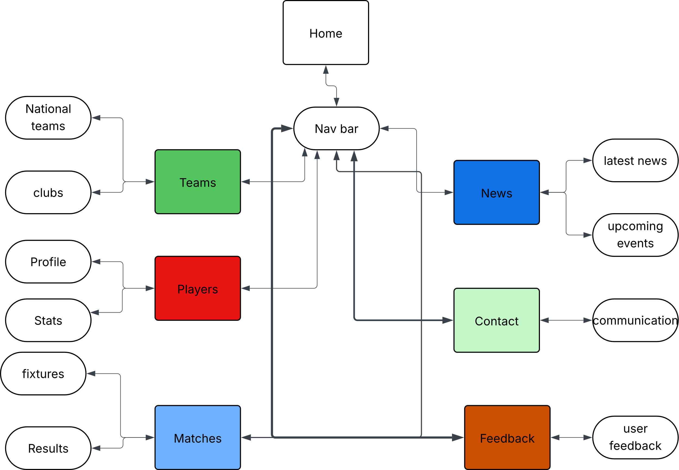

- Navigation Design
- A top navigation bar will be used on all pages
- Users can access any page within 3 clicks (3-click rule)
- Consistent layout across all pages ensures usability

- Content Categorization (Taxonomy)
Content will be grouped as follows:
- Teams: National team squads and football clubs
- Players: Player profiles and statistics
- Matches: Fixtures and results
- News: Latest football news, upcoming football events
- Contact: communication
- Feedback: user feedback
3. Technical Brief
- Technologies Used
The website will be developed using the following technologies:
- HTML5
Used to create the structure of the web pages
- CSS3
Used for styling, layout, and visual design
- JavaScript
Used for interactivity and form validation
- Bootstrap Framework
Used to create responsive and mobile-friendly layouts

- Development Tools
- Visual Studio Code (VS Code)
Used as the main code editor
- GitHub
Used for version control and storing project files
- GitHub Pages
Used to host and publish the website online

- Graphic & Media Tools
- GIMP / Canva
Used to design logos, banners, and images
- Online Image Sources
Used for football-related images (players, stadiums, etc.)

- Browser & Device Compatibility
The website will be tested on:
- Google Chrome
- Mozilla Firefox
- Microsoft Edge
It will also be optimized for:
- Mobile phones
- Tablets
- Desktop screens

- Additional Features
- Responsive design
- Navigation bar on all pages
- Contact form with validation
- Use of images and multimedia

